Lesson 2

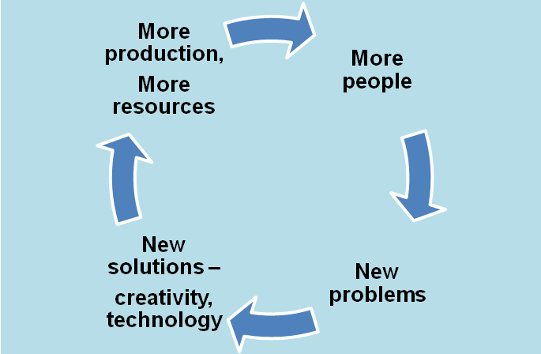

Ongoing development as represented in the feedback loop above resulted in larger groups of people living in cities with social hierarchies and intensified agriculture. The first known examples of these were the river valley civilizations.

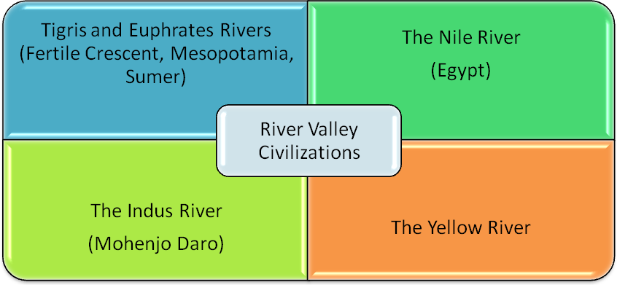

Big Idea Card

|  |
| --- |
| Big Ideas of Lesson 2, Unit 3 |
| * Civilization in Afroeurasia developed around river valleys at the Tigris and Euphrates in Mesopotamia, the Nile in Egypt, the Indus River in modern India/Pakistan, and the Yellow River (Huang He) in modern China. * These areas had climactic features and natural resources which facilitated the intensification of agriculture and allowed for larger groups of people to live there. * As civilizations developed, new problems emerged which necessitated new solutions, and innovation occurred at a faster pace in a variety of areas including technology, government, culture and art, and writing. New systems of social hierarchy also developed. * The largest settlements of humans developed into cities, and over time, more and more people began to live in cities... a trend that continues today. |

Word Cards

Word Cards from previous lessons needed for this lesson:

* **civilization** – Word Card #1 from Lesson 1
* **specialization -** Word Card #2 from Lesson 1
* social hierarchy **-** Word Card #3 from Lesson 1
* **river valley civilization** - Word Card #4 from Lesson 1

|  |  |
| --- | --- |
| 7  intensification  Description: http://answeron.com/wp-content/uploads/2011/05/graph-increase.jpgaction or process that makes something stronger or more extreme; the process of change and growth in Era 2  Example: Urbanization is a result of the intensification of the rapid change and growth in cities.  (SS070302) | **8**  **Mesopotamia/Sumer**  [See full size image](http://ancienthistory.mrdonn.org/meso05.gif)the civilization that developed around the Tigris and Euphrates rivers around 3500 BC/BCE  *Example:* Sumer was a complex ancient civilization that exists in modern Iraq.  (SS070302) |
| http://www.ilike2learn.com/ilike2learn/Rivers/Nile%20River.jpg9  Nile River  the longest river in the world located in Northeastern Africa.  *Example:* Cities developed along the Nile River and were unified into a complex society over five thousand years ago.  (SS070302) | http://www.ilike2learn.com/ilike2learn/Rivers/Indus%20River.jpg10  **Indus River**  a large river surrounded by fertile land in modern India/Pakistan.  ***Example:***The Harrapan culture developed along the Indus River during Era 2.  (SS070302) |
| 11  Yellow River  http://www.ilike2learn.com/ilike2learn/Rivers/Huang%20He%20(Yellow%20River).jpga large river in northern China, where Chinese civilization developed  ***Example:***The Shang dynasty ruled the Yellow River valley for 500 years.    (SS070302) | http://upload.wikimedia.org/wikipedia/commons/thumb/4/4b/Map_of_fertile_cresent.svg/350px-Map_of_fertile_cresent.svg.png**12**  **Fertile Crescent**  the crescent-shaped area of arable land, that is considered the cradle of civilization  ***Example:*** The Fertile Crescent was home to the earliest known western civilizations.  (SS070302) |

Handout 1: Characteristics of a Civilization

**Intensification:** Neolithic villages became larger and denser as populations grew, architecture expanded, and a food surplus was available. After 4000 BC/BCE, great changes occurred in cultural institutions. These changes occurred very quickly considering humans had lived at foragers and in small farming villages for over 200,000 years before this. This process of change and growth in Era 2 is called intensification. A society did not have to have every characteristic to be a civilization, but below represent some general trends.

|  |  |
| --- | --- |
| Characteristic | Description |
| Cities | Cities supported large populations of over 30,000 people |
| Specialization | Some people living in cities took full-time specialized jobs (artisan, merchant, soldier, priest) because they were supported by farmers from the surrounding community. |
| Hierarchy | A class system emerged where certain men (and sometimes women) held all the power. They were called elites. Men began to dominate in politics and women became more responsible for the life at home. This system is called patriarchy. |
| The State | One city usually ruled over all others in a civilization. A king or pharaoh with a small group of officials controlled the rest of society. |
| Networks of Trade | Many civilizations traded within and outside of their borders. Technology, food, and language spread from Mesopotamia outward to Egypt, India, and China. |
| Technology | Technology changed much more rapidly than in Era I. People developed metals like bronze and use those build things like wheeled carriages. |
| Monuments | Large buildings were constructed like city walls, temples, palaces, and tombs for powerful rulers. |
| Spiritual Beliefs and Laws | Spiritual beliefs and laws became richer and more complex. |
| Creativity | Individuals worked with the ruling class to study astronomy, mathematics, sciences, and engineering. |

Handout 2: Early Cities

Adapted from Big History by Cynthia Stokes Brown (2007)

“Were these four societies civilization?” As you read, identify evidence that will help you answer this question and determine if they meet the criteria for civilization.

The first cities developed in about 3500 BCE in four river valleys across Afroeurasia. The earliest cities appeared in the Tigris and Euphrates valleys in what is now southern Iraq. Cities also appeared in the Nile valley in Egypt, the Indus valley in Pakistan/India, and in the Yellow River valley in China. All of these cities were supported by farming in the river valley areas, although the specific crops varied by place. They all also had domesticated animals which provided food as well.

Mesopotamia-Sumer

The name Mesopotamia actually means “land between rivers” in ancient Greek. This society, also known as Sumer, is an ancient civilization of cities that developed on the Tigris and Euphrates rivers over five thousand years ago.

The first of eight Sumerian cities to develop was Uruk. Uruk had two major temples. One was to An, the sky god and another to Inanna the goddess of love and protection. Each major city in Sumer was devoted to one or more gods. The Sumerians believed that the gods resided in the temples they built for them.

Sumerians believed in seven major gods and goddesses, who formed a council that decided what would happen to people. The four gods were An (sky), Enlil (air), Enki (water and wisdom), and Utu (sun). The three goddesses were Ki (Earth), Nannar (moon), and Inanna (love and protection). People in Sumer ranked gods just like they were ranked when hierarchies appeared. The major gods lived in temples that formed large towers called ziggurats.

Over time, the cities of Sumer were united. King Sargon of the city Akkad conquered the other cities, demolished their walls, and appointed his sons as governors. Sumer was now ruled by one city and its ruler controlled others, supported by scribes and priests. Sargon’s grandson, Naram Suen, declared himself a god.

Indus River Civilization

People began living in the Indus Valley in about 7000 BCE and on the Indus River by 3000 BCE. Archeologists have excavated two Indus Valley cities, Mohenjo Daro and Harappa. Scholars have not been able to decipher Indus script, so not much is known about their culture.

Scholars do know that the people of Mahenjo Daro and Harappa were able to separate drinking water from waste-water in the first known sewage system. Some carvings on artifacts found in these cities may depict some early forms of Hindu gods. By 1500 BCE life on the Indus River had disappeared. Scholars think there may have been an earthquake or a flood that made life difficult. Another possibility is that farming became difficult because of salinization. Salinization occurs when land gets too much salt caused by the evaporation of water. Since even fresh water has small amounts of salt in it, the same problem could have caused the decline of ancient Sumer as well.

Egypt

Fortunately, scholars have been able to decipher Egyptian hieroglyphics, a form of writing that Egyptians developed around 3300 BCE. Scribes or record keepers who could read and write well, kept information on an early form of paper called papyrus. Documents reveal that Egyptian settlements were united in about 3100 BCE and ruled from a city called Memphis on the Nile River Delta.

The Nile River, the longest river in the world at 4,160 miles, gave Egyptians many advantages. It provided transportation by boat that allowed their ruler, called a pharaoh, to control the distribution of resources through the kingdom. Since the river flooded annually, Egyptians farmers were able to trap water in deposits of soil to water their crops. Salinization occurs when water evaporates leaving too much salt. Because there was less evaporation here, agriculture lasted much longer than in the Indus Valley or in Sumer.

In 1687 BCE, Egypt was invaded by a people called the Hyksos who rode horse drawn chariots. This drew Egypt into warfare and Egypt ruled the Nile far to the south and as far as the Euphrates River in the north.

Yellow River

In China, in the far eastern part of Eurasia, a fourth civilization developed. Early Chinese cities developed on the agricultural surplus produced near the Yellow River. Urban areas evolved from villages on terraced land near the Yellow River. By 3000 BCE there were walled villages in northern China with richly appointed tombs containing pottery with mark that appeared to be ancient Chinese script.

By 1523 BCE, the Shang family had established military and political power by importing weapons from the Middle East. The Shangs ruled for 500 years. Their capital was in Anyang, now in the Honan province of modern China.

During the Shang dynasty, elites, or people at the top of the social hierarchy used bronze to make cooking pots and other artifacts. Bronze was also used for wheeled vehicles. They made books out of bamboo and used brushes for writing. There is also evidence they practiced human sacrifice.

Handout 3- River Valley Civilizations Graphic Organizer

|  |  |  |  |  |
| --- | --- | --- | --- | --- |
|  | Mesopotamia-Sumer | Indus | Egypt | Yellow River |
| Dense Population  (more people in smaller space) |  |  |  |  |
| Agricultural Economy  (farming as main activity) |  |  |  |  |
| Cities |  |  |  |  |
| Complex Social Hierarchy (levels of power) |  |  |  |  |
| Occupational Specialization (special jobs needing certain skills) |  |  |  |  |
| Centralized State (a main authority making decisions) |  |  |  |  |
| Architecture (monument building) |  |  |  |  |
| Writing System |  |  |  |  |
| Belief System (religion or other cultural system of shared beliefs) |  |  |  |  |

TEACHER REFERENCE GUIDE: Handout 3- River Valley Civilizations Graphic Organizer

|  |  |  |  |  |
| --- | --- | --- | --- | --- |
|  | Mesopotamia-Sumer | Indus | Egypt | Yellow River |
| Dense Population  (more people in smaller space) | 8 large cities | yes, two cities | yes, in Nile Delta, Memphis | walled villages |
| Agricultural Economy  (farming as main activity) | yes | yes | yes | yes |
| Cities | 8 large cities | Mohenjo Dara, Harappa | Memphis | Anyang |
| Complex Social Hierarchy (levels of power) | major temples, King Sargon | not clear, but two main cities... probably | yes, pharoah, scribes, trade | yes, dynasty, Shang family, trade, elite class, tombs |
| Occupational Specialization (special jobs needing certain skills) | yes  farmers,  scribes, priests | farming, sculptors | scribes | trade, weapons, scribes |
| Centralized State (a main authority making decisions) | yes... King Sargon | not clear, but two main cities | yes, pharoah | Shang dynasty, elite class |
| Architecture (monument building) | major temples | sewage system | no mention here, but probably | walled villages, tombs |
| Writing System | mention of scribes | yes, script | hieroglyphics | ancient Chinese script |
| Belief System (religion or other cultural system of shared beliefs) | several gods with temples | early Hindu gods, maybe | not clear in text | not clear, maybe human sacrifice |

**Small Group Discussion Questions**

Talk about these questions in your group, going back to your charts and the text for help with your thinking. Have a note taker for each question, taking turns at this job during your conversation, but be sure that everyone in your group writes down the answers to each question by the end of the activity.

1. What evidence is listed in the reading for complex societies in these four examples?
2. Which civilizations do we seem to know more about, why do you think that is?
3. Why did civilization last longer in Egypt and China?

**TEACHER REFERENCE GUIDE -- Small Group Discussion Questions**

Talk about these questions in your group, going back to your charts and the text for help with your thinking. Have a note taker for each question, taking turns at this job during your conversation, but be sure that everyone in your group writes down the answers to each question by the end of the activity.

1. What evidence is listed in the reading for complex societies in these four examples?

*Students should be able to pick up on the clues that all of these civilizations were developing social hierarchies and more complex cultures. They should be able to use examples from their chart... evidence of writing systems, architecture, governments, etc.*

1. Which civilizations do we seem to know more about, why do you think that is?

*From these paragraphs, there seems to be more information on Sumer and Egypt. This is likely because more of their writing survived and because we have learned to decipher it. In the case of Egypt, the civilization lasted longer than it did in other places because the farming was not damaged by salinization.*

1. Why did civilization last longer in Egypt and China?

*Civilization lasted longer in Egypt and China likely for several reasons: conquest, trade, and more consistent farming are a few that students might touch upon.*